TIFF Climate_Report_Figure_3 2011JULY03.tif

Climate Linkage Mapper User Guide

**Linkage Mapper Toolbox:**

**Climate Linkage Mapper User Guide**

*Version 3.0—Updated July 2021*

Darren Kavanagh1, Tristan Nuñez 2, and Brad McRae3

1Torilis, LLC

2University of California, Berkeley

3The Nature Conservancy

**Acknowledgements**

Climate Linkage Mapper builds upon the Python code developed by Tristan Nuñez as part of his master’s work (Nuñez 2011, Nuñez et al. 2013). We are grateful to our collaborators in the Climate Change Subgroup of the Washington Wildlife Habitat Connectivity Working Group for their feedback and assistance, and to Jenny McGuire for testing and suggesting improvements to the user guide.

**Software Requirements and Licensing**

Climate Linkage Mapper only runs on Microsoft Windows platforms. It requires **ArcGIS Desktop** (10.3 or greater with Advanced license) or **ArcGIS Pro** (Advanced license), with the **ArcGIS Spatial Analys**t extension and **GRASS GIS**. This software is provided free of charge and is licensed under a GNU General Public License.

**Preferred Citation**

Kavanagh, D.M., T.A. Nuñez, and B.H. McRae. 2013. Climate Linkage Mapper Connectivity Analysis Software. The Nature Conservancy, Seattle WA. Available at: <https://circuitscape.org/linkagemapper/>.

**Table of Contents**

[1 Introduction 3](#_Toc76917841)

[2 Installation 3](#_Toc76917842)

[3 Using Climate Linkage Mapper 3](#_Toc76917843)

[3.1 Input data requirements 3](#_Toc76917844)

[3.2 Running from a Python Script 5](#_Toc76917845)

[3.3 Processing Steps 6](#_Toc76917846)

[4 Climate Linkage Mapper DEMO 7](#_Toc76917847)

[5 Extra hints 7](#_Toc76917848)

[5.1 Background processing on ArcGIS Desktop 7](#_Toc76917849)

[5.2 Changing linkage rules without re-starting from scratch 7](#_Toc76917850)

[6 Community 8](#_Toc76917851)

[7 Literature cited 8](#_Toc76917852)

# Introduction

Climate Linkage Mapper is part of the Linkage Mapper toolbox, which includes the Linkage Pathways Tool (McRae and Kavanagh 2011) and other modules designed to support regional wildlife habitat connectivity analyses. The tool is designed to create linkages between designated core areas that fall along a climatic gradient (e.g. temperature). More details on climate corridor theory and approaches to modeling climate corridors can be found in Nuñez (2011) and Nuñez et al. (2013), Washington Wildlife Habitat Connectivity Working Group (WHCWG) (2011) and WHCWG (2012).

# Installation

**1) Download and Install Linkage Mapper**

Download and install the Linkage Mapper toolbox from <https://circuitscape.org/linkagemapper>. Open the zip archive and place the *toolbox* directory with all its contents on your computer. Place the *demo* directory in a folder that has no spaces or special characters in its path. To install the toolbox follow the instructions in the Linkage Pathways User Guide (McRae and Kavanagh 2011), which is also included in the download.

**2) Download and Install GRASS GIS**

Download GRASS GIS 7.8 from <https://grass.osgeo.org/download/windows/>. To install run the downloaded installation file and follow the on-screen instructions. Please insure that the GRASS application will start. If you experience startup errors some solutions can found at <https://grasswiki.osgeo.org/wiki/WinGRASS_errors>.

# Using Climate Linkage Mapper

To start Climate Linkage Mapper select the *Linkage Mapper* toolbox (see Figure 1) in ArcGIS, and click on *Climate Linkage Mapper*. The dialog illustrated in Figure 2 should appear. A description of each parameter follows below.

## Input data requirements

1. **Model Inputs**
   1. **Project Folder:** This is the windows folder where the final output will be saved. It is also used by the tool to store temporary outputs. This folder should be in a shallow tree and have a short name (something like C:\ANBO), ideally on a local drive for optimum processing speed and reliably. The name of the directory will also be used as a prefix for final Linkage Pathways output files (e.g. ANBO\_LCPs). There should be no spaces or special characters anywhere in the folder path.

Figure 1. Linkage Mapper Toolbox

* 1. **Core Area Feature Class:** Enter the polygon feature class (e.g. shape file) that contains the core areas (the polygons that will be connected with linkages).

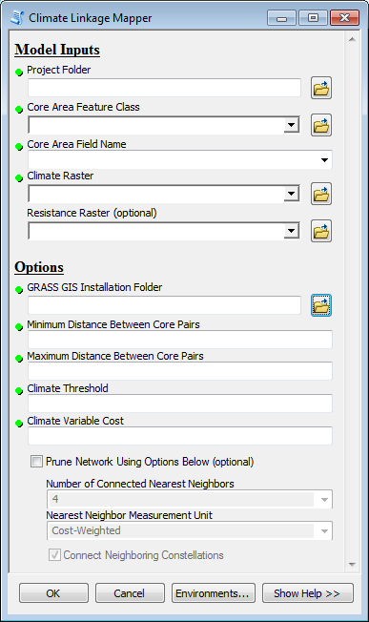

Figure 2. Climate Linkage Mapper Input Screen in ArcGIS Desktop

* 1. **Core Area Field Name:** This drop-down listwill list all attribute fields in the core feature class. The selected field must consist of positive integers < 9999 that uniquely identify unique core areas. FID and ID fields cannot be used. An easy way to create a new field is to open the attribute table, add a new integer field and use the field calculator to fill it with an expression like <NewField> = FID + 1.
  2. **Climate Raster:** Enter the climate (e.g. temperature) surface here. This can be in any standard raster format that ArcGIS accepts.
  3. **Resistance Raster** (optional)**:** To optionally incorporate other impediments to movement, in addition to climatic variability, a resistance raster can be entered here. See the Linkage Pathways Tool User Guide (McRae and Kavanagh 2011) for tips on creating a resistance raster.

1. **Options**
   1. **GRASS GIS Installation Folder:** For the tool to work correctly you must tell it where GRASS GIS is installed. On Windows 10 (64-bit) the default folder is *C:\Program Files\GRASS GIS 7.X.X*.
   2. **Minimum Distance Between Core Pairs:** Enter the minimum edge-to-edge linkage distance that should separate one core to another. Linkages less than this distance will not be created. The distance unit is that of the input spatial layers.
   3. **Maximum Distance Between Core Pairs:** Enter the maximum edge-to-edge linkage distance that should separate one core to another. Linkages greater than this distance will not be created. The distance unit is that of the input spatial layers. **NOTE:** least-cost corridors can still be longer than this distance, as they will typically be considerably longer than the edge-to-edge distance between the core pairs they are connecting.
   4. **Climate Threshold:** A positive numeric value, in the same units as the climate raster, that limits core pairs based on climate. Core areas will only be connected if the difference between the lowest climate values is greater than the threshold. To avoid outliers, this value is two standard deviations below the mean of the core (see Nuñez 2011 and Nuñez et al. 2013 for more discussion on this topic).
   5. **Climate Variable Cost:** This is the distance to climate ratio, in cost-distance units per unit change in climate. It is used to calculate the anisotropic cost distance between cores. For example, 50000 is the appropriate value for a distance-to-temperature ratio of 50 km/1°C, where the map units are in meters (see Nuñez 2011 and Nuñez et al. 2013 for more discussion on this topic).
   6. **Prune Network Using Options Below (optional):** The number of corridors mapped can be optionally limited based on the following parameters. (This section is equivalent to Step 4 in the Linkage Pathways Tool).
      1. **Number of Connected Nearest Neighbors:** The number of nearest neighbors to connect each core to. Any links that are not needed to connect each core to its N nearest neighbors are dropped. Allowable range is 1-4.
      2. **Nearest Neighbor Measurement Unit:** Choose whether to measure ‘nearest’ above in Euclidean or cost-weighted distance.
      3. **Connect Neighboring Constellations:** If this option is selected links will be re-added to connect nearest pairs of core area ‘constellations’, i.e. discrete clusters of neighboring core areas, until all constellations are connected.

*Please note that all input spatial layers should be in the same coordinate system. The tool assumes that they are. Furthermore, the spatial extent of the analysis will be the intersection of the input layers.*

Climate Linkage Mapper can be run once all the parameters are correctly populated and the OK is pressed. Figure 4 in section 4 illustrates a completed tool screen.

*If you get a conflict between ArcGIS Desktop and GRASS, you should first try running Climate Linkage Mapper in the background. See section 5 below.*

## Running from a Python Script

Climate Linkage Mapper can also be invoked programmatically outside of ArcGIS Desktop or ArcGIS Pro, although there are many advantages in running it within ArcGIS. The tool is written in Python and can be initiated by calling *cc\_main.py* (in the Linkage Mapper *scripts* folder) with the appropriate input parameters. The Python script, *CC Run Script.py*, in the Linkage Mapper *demo* folder gives an example that can be modified to match your needs.

## Processing Steps

To generate climate corridors Climate Linkage Mapper runs through a series of computational steps. Some of these steps are logged and reported in the tool’s *Details* window (see Figure 3). These can be helpful in monitoring the tools progress and identifying problems. The main steps are listed below along with a brief description of the action they carrying out:

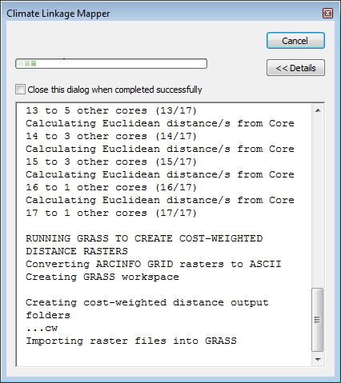

Figure 3. Details Screen in ArcGIS Desktop

1. **Copy spatial data:** The tool copies the spatial inputs into the *clm\_cor* folder within the project folder and, if necessary, reduces their extent.
2. **Calculate zonal statistics:** To get a statistical summary of climate values in each core area the tool calls ArcGIS’s *Zonal Statistics as Table* function.
3. **Create core pairing table:** A unique set of core to core pairings are created. For example, if you have 3 cores, you end up with 3 core pairings – (Core1-Core2, Core1-Core3, Core2-Core3).
4. **Limit cores based upon climate threshold:** The lowest mean values are calculated and core pairings with a mean difference lower than the threshold are removed.
5. **Limit cores based on Euclidean distances and create link table for Linkage Pathways:** Core pairs are next filtered by the minimum and maximum distance separating them. A Linkage Pathways link table is created along with the final core pairings.
6. **Run GRASS GIS to create cost-weighted distance rasters:** The anisotropic cost distance between the different core pairings are calculated using GRASS GIS’s r.walk function. As GRASS has its own unique spatial file structure, all inputs have to be imported into a temporary GRASS database.
7. **Run Linkage Pathways to create climate corridors:** Once all the cost distance rasters are generated, the tool calls Linkage Pathways to create the climate corridors. Linkage Pathways is started at *Step 3*. Final output can be found in the *output* folder within the project folder**.** More details on Linkage Pathways outputs can be found in its user guide (McRae and Kavanagh 2011).

Four output files are maintained from steps *a* thru *f* – the core feature class, the project resistance raster, the zonal statistics table and the final core pairing table. These can be found within the *clm\_cor* folder. The project resistance raster will be named *projarea* if no resistance raster was provided.

*To change the number of nearest neighbors linked or to manually adjust the links mapped it is not necessary to re-run the tool as Linkage Pathways can be restarted independently at step 4. See section 5 below.*

# Climate Linkage Mapper DEMO

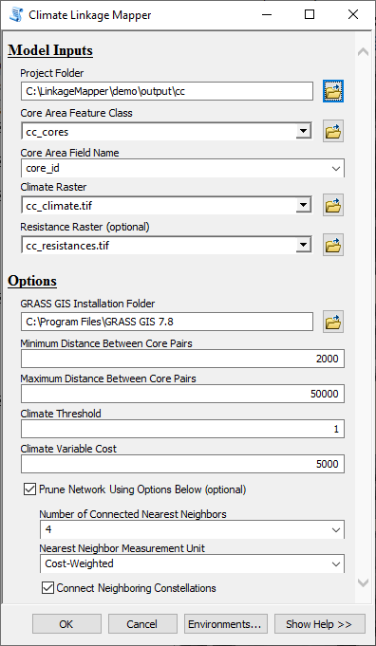The Linkage Mapper download comes with sample data that can be used to evaluate and test the Climate Linkage Mapper tool. The easiest way to explore the demo data is to open the ArcGIS map document *CC Demo.mxd* or the *CC Demo* map in *ArcGIS Pro Demo.aprx* in the Linkage Mapper *demo* folder. To run the demo click on the Climate Tool and enter the *Model Inputs* as illustrated in Figure 4 (substituting the path to the installed *demo* folder and the GRASS GIS installation folder). While the other options do not have to be followed, those illustrated have been tested to generate output. The final output can be reviewed in a separate map document - *CC Demo Results.mxd*. For more information how to interpret Linkage Pathways outputs please see the Linkage Pathways Tool user guide (McRae and Kavanagh 2011).

# Extra hints

## Background processing on ArcGIS Desktop

Climate Linkage Mapper when running on ArcGIS Desktop executes best in the background- this helps to avoid conflicts between ArcGIS and GRASS. Right-click on the Climate Linkage Mapper tool shown in Figure 1, click ‘properties,’ and un-check ‘Always run in foreground.’ You will want to show the Results window so that you can monitor program progress and cancel runs (click Geoprocessing>>Results). The Results window also lets you start new runs with the same settings used earlier runs.

Figure 4. Climate Linkage Mapper DEMO

## Changing linkage rules without re-starting from scratch

To change the number of nearest neighbors linked or to manually adjust the links mapped it is not necessary to re-run the tool as Linkage Pathways can be restarted independently at step 4.

The spatial inputs for Linkage Pathways are stored in the *clm\_cor* folder within the project directory. See the Linkage Pathways Tool user guide for instructions on starting at step 4 (be sure to un-check steps 1-3) and on manually removing or retaining links.

# Community

Please join the Linkage Mapper Google Groups forum at <https://groups.google.com/g/linkage-mapper> to get updates, report bugs, and suggest enhancements. Please also visit the project website at <https://circuitscape.org/linkagemapper/>.

To contribute to the development of Linkage Mapper explore our code repository on GitHub: <https://github.com/linkagescape/linkage-mapper>.

# Literature cited

McRae, B.H. and D.M. Kavanagh. 2011. Linkage Mapper Connectivity Analysis Software. The Nature Conservancy, Seattle WA. Available at: <https://circuitscape.org/linkagemapper>.

Nuñez, T.A. 2011. Connectivity Planning to Facilitate Species Movements in Response to Climate Change. Available at <https://waconnected.org/climate-change-analysis/>.

Nuñez, T.A., J.J. Lawler, B.H. McRae, D.J. Pierce, M.B. Krosby, D.M. Kavanagh, P.H. Singleton, and J.J. Tewksbury. 2013. Connectivity planning to address climate change. Conservation Biology.

Washington Wildlife Habitat Connectivity Working Group (WHCWG). 2011. Washington Connected Landscapes Project: Climate-Gradient Corridors Report. Washington Departments of Fish and Wildlife, and Transportation, Olympia, WA. Available at <https://waconnected.org/climate-change-analysis/>.

WHCWG. 2012. Climate Gradient Corridor Report: Frequently Asked Questions. Departments of Fish and Wildlife, and Transportation, Olympia, WA. Available at <https://waconnected.org/climate-change-analysis/>.